Project Design Phase-II
Technology Stack (Architecture & Stack)

Date | 11 July 2026
Team ID | N/A
Project Name | STOCK TRADING APP
Maximum Marks | 4 Marks

STOCK TRADING APP Technical Architecture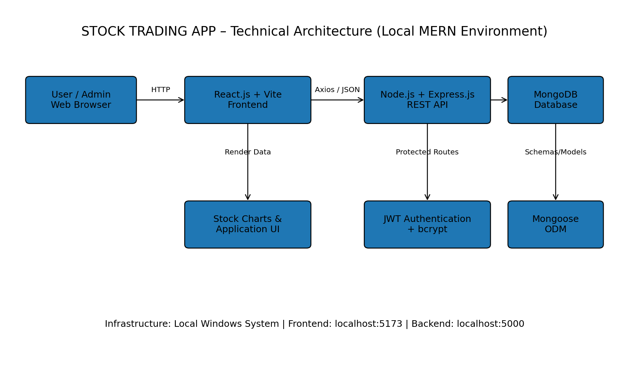
Technical Architecture:
The Deliverable shall include the architectural diagram as below and the information as per the table1 & table 2
Example: Order processing during pandemics for offline mode
Reference: https://developer.ibm.com/patterns/ai-powered-backend-system-for-order-processing-during-pandemics/
Guidelines:
Include all the processes (As an application logic / Technology Block)
Provide infrastructural demarcation (Local / Cloud)
Indicate external interfaces (third party API’s etc.)
Indicate Data Storage components / services
Indicate interface to machine learning models (if applicable)


Table-1 : Components & Technologies:
S.No | Component | Description | Technology
1. | User Interface | Responsive web interface for users and administrators, including authentication, stocks, portfolio, wallet, orders, history and admin dashboard. | React.js, Vite, CSS, React Router
2. | Application Logic-1 | Client-side routing, UI state, API communication and rendering of application data. | React.js, Axios, React Router
3. | Application Logic-2 | RESTful backend APIs for authentication, profiles, stocks, orders, portfolio, wallet and administrative operations. | Node.js, Express.js
4. | Application Logic-3 | Authentication and authorization for protected application routes. | JSON Web Token (JWT), bcrypt
5. | Database | NoSQL storage for application data such as users, stocks, orders, portfolio and transactions. | MongoDB, Mongoose
6. | Cloud Database | Not used in the submitted local version. The application can be configured with MongoDB Atlas in future if required. | Not implemented / Future: MongoDB Atlas
7. | File Storage | Project source code, screenshots, documentation and demo resources are maintained using repository/local or Drive-based storage. | Local File System, GitHub, Google Drive
8. | External API-1 | No external live stock-market API is used in the current version; stock prices are simulated within the application. | Not implemented
9. | External API-2 | No additional third-party external API is required in the current implementation. | Not implemented
10. | Machine Learning Model | No machine learning model is required or implemented for the current stock trading simulation application. | Not applicable
11. | Infrastructure (Server / Cloud) | Application is executed locally. Frontend development server runs on port 5173 and backend server on port 5000. MongoDB must be available locally or through a configured connection string. | Local Windows system; Node.js runtime; Vite development server; Express server; MongoDB

Table-2: Application Characteristics:
S.No | Characteristics | Description | Technology
1. | Open-Source Frameworks | Open-source libraries and frameworks are used across the frontend, backend and database integration. | React.js, Vite, Node.js, Express.js, Mongoose, Axios, React Router
2. | Security Implementations | Passwords are hashed and authenticated sessions use token-based authorization. Protected routes restrict unauthorized access and secrets are stored as environment variables. | JWT, bcrypt, dotenv, Express middleware
3. | Scalable Architecture | The application follows a modular three-layer MERN structure separating presentation, application/API logic and data storage. Routes, controllers and models can be extended independently. | React.js, Express.js, Node.js, MongoDB/Mongoose
4. | Availability | The submitted version is a local application and is available while MongoDB, the backend server and frontend server are running. Cloud deployment can improve future availability. | Local deployment; Future deployment can use Render/Vercel or similar services
5. | Performance | Vite provides efficient frontend development and React component rendering. REST APIs and MongoDB/Mongoose support structured data access for normal project-scale usage. | Vite, React.js, Express.js, MongoDB/Mongoose

References:
https://c4model.com/
https://developer.ibm.com/patterns/online-order-processing-system-during-pandemic/
https://www.ibm.com/cloud/architecture
https://aws.amazon.com/architecture
https://medium.com/the-internal-startup/how-to-draw-useful-technical-architecture-diagrams-2d20c9fda90d

